Petri de Villiers

MScEng (2015, Structural Engineering, Stellenbosch)

Email: jpdv@sun.ac.za
Telephone: +27 836522689
Read my CV here

Research topic: Bond behaviour of deformed steel reinforcement in lightweight foamed concrete

Status: In progress (2014-)

Project description:

1. Problem statement and introduction
2. Proposed Study
3. Tests

Scholarship:
Wilhelm Frank scholarship for M.Eng studies at Stellenbosch University.
1. Problem Statement and Introduction

Foamed concrete (FC) has many attractive properties which should entice structural engineers world-wide to design and implement this energy saving material. The use of FC provides many cost saving solutions which is key for developing countries and the increasing demand for energy effective systems. FC has a high workability, which includes self-compacting and self-levelling, and exhibits excellent thermal insulating properties. Most of all the density of FC is much less than normal weight concrete (NWC) which makes the FC the lighter design option. The question arises why is there no clear shift towards structural application of FC, which clearly, poses a more economic structural solution?

The answer is proclaimed that the unfamiliarity with FC and the design thereof, seems to push design engineers away from FC to NWC, which is thoroughly standardised and familiar in practice. It is therefore of utmost importance that research be executed in order to set up design guidance for the structural use of FC.

FC has many obvious advantages, but there are a few issues that require attention before this material can effectively be identified as a suitable, safe en predictable structural material. This study will be conducted with a specific end deliverable as goal; identifying the general engineering parameters and material interaction properties associated with (reinforced) lightweight foamed concrete. This ensures the further development and effective use of this energy saving material, for various structural concrete applications. The focus will fall on the bond relation between the reinforcing steel and the LWFC and how the design of a NWC structure compares to that designed with LWFC. Design standards do not yet accommodate LWFC, as is done in an extensive clause in the British standards (BS EN 1992-1-1, 2004), which comprehensively alters design criteria for lightweight aggregate concrete (LWAC).

2. Proposed Study

The proposed study will be done in four phases. The first phase will deal with the experimental tests in order to classify the behaviour of the material with the focus on the bond characteristics at the concrete-reinforcing steel interface. The second phase will incorporate an analytical model to simulate the material behaviour found in phase one. The third phase will use the knowledge found from phases one and two to compare the criteria to those found in existing LWC design specifications (BS EN 1992-1-1, 2004). The final phase will comprise of a typical structural design to be tested in a laboratory experiment. This will be done along with a brief economic study to determine whether the reduced use of materials (lightweight concrete), and therefore saving of money, is significant relative to the extra steel (increased cost) needed because of a change in the bond strength between steel and LWC, as opposed to NWC.

There was a tendency found in literature that typical pull-out tests do not simulate true bond behaviour of a structural element induced to typical service loads. Therefore the bond relation will be based on beam-end specimens according to ASTM A944 which more accurately simulates a concrete beam under flexural loading. The beam-end specimen is shown in Figure 1. Figure 2 show the beam-end specimen setup in which effectively pulls the embedded steel bar out of the concrete specimen. The supports on the sides ensure the beam end specimen to be subjected to typical beam loading conditions.
(back)

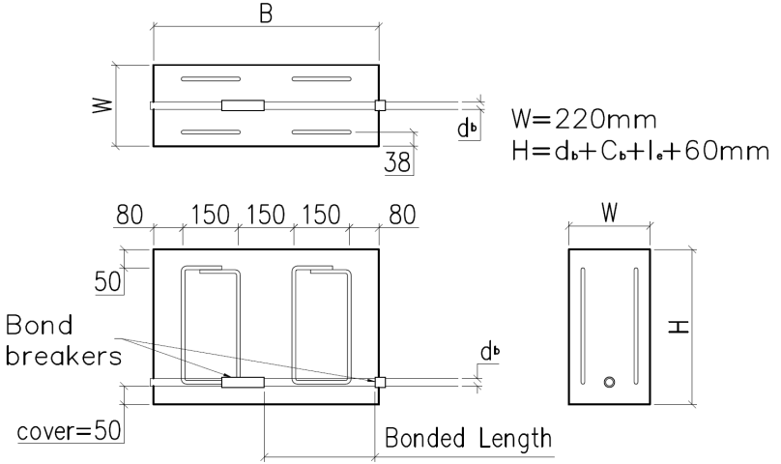
Figure 1 – Beam-end specimen to be used in the proposed study to obtain accurate bond relation.

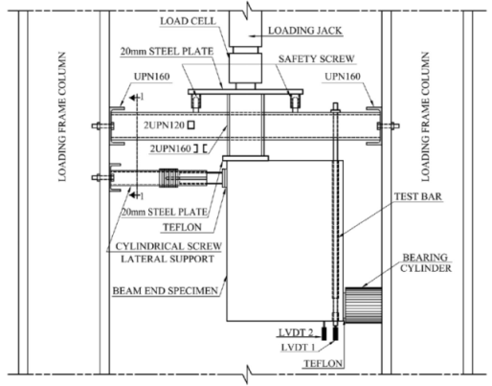
Figure 2 – Beam end specimen in test setup.

The analytical model will be constructed according to the data obtained from the beam-end pull-out tests. This model will be based on previous, in depth studies conducted by various contributors into the bond relation of deformed steel reinforcement in NWC. The relation obtained is shown below with the parameters considered.

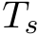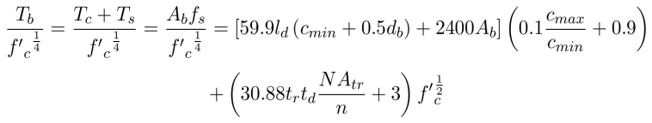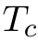

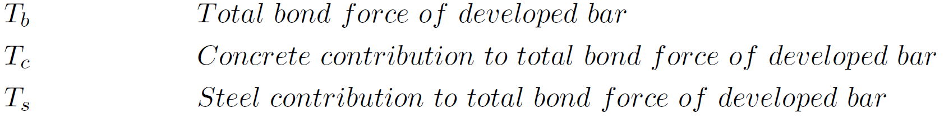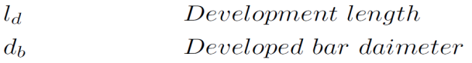

(back)

2. Tests
The tests to be performed in this study include the beam-end tests introduced in section 1 and are tabulated in the table below. Two embedment lengths will be investigated (150mm and 300mm) and two bar diameters (10mm and 20mm), 2 types of concrete: NWC (30 MPa) and LWFC (1400 kg/m³, 1600 kg/m³ and 1800 kg/m³).

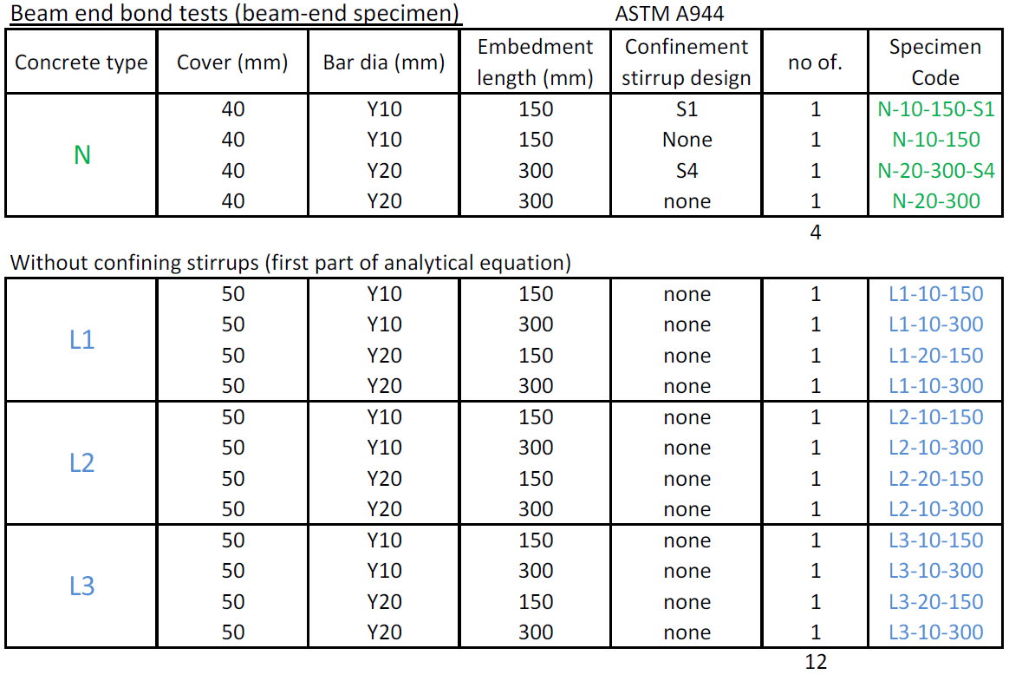

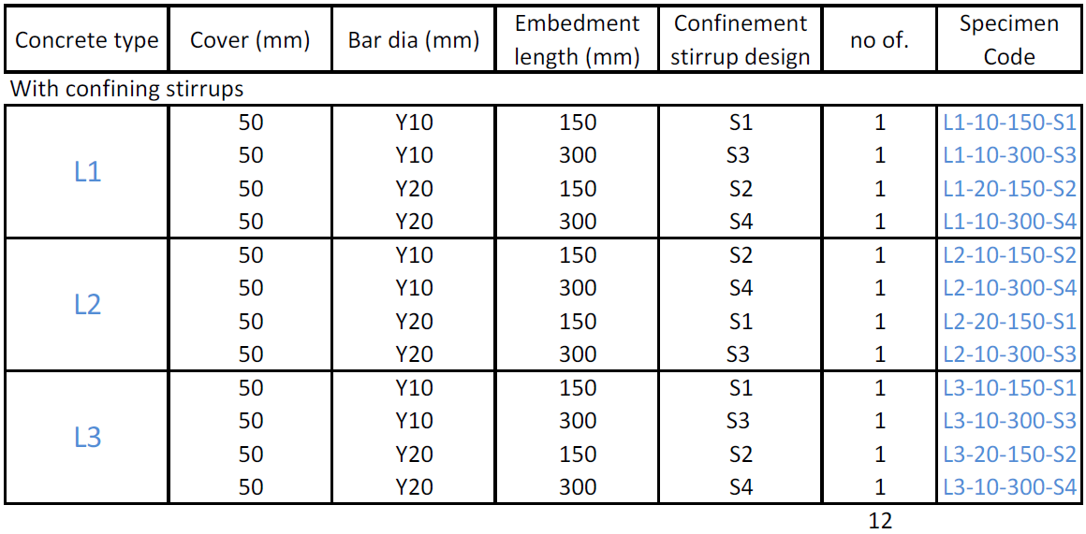

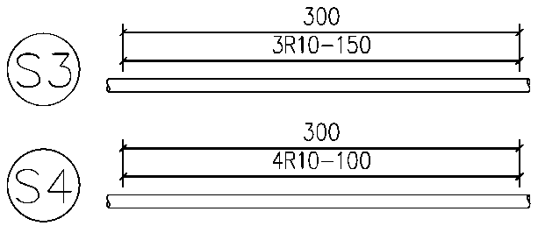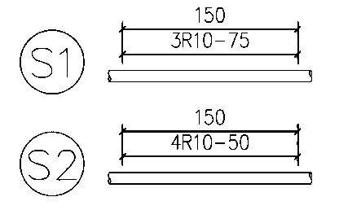

(back)
(back to JPdeVilliers)
(back to People)
(back to projects)

