Andrew Christopher Way

MEng (2014, Stellenbosch University)

Email: Acway@sun.ac.za / Roo.c.way@gmail.com
Telephone: 072 679 0586

Research Topic: A Study on the Design and Material Costs of Tall Wind Turbine Towers in South Africa.
Status: Completed 2013-2014.

Project Description:
- Aims and methodology
- Wind resource analysis
- Structural design and FEM
- Results
- Conclusions

Publications/Presentations:
Way, AC 2014. A study on the design and material costs of tall wind turbine
towers in South Africa, MEng-thesis, Stellenbosch University.

Way, AC 2014. A study on the design and material costs of various designs of tall wind turbine
towers in South Africa. Proceedings 1st International Seminar on the Design of Wind Turbine Support
Structures. Stellenbosch, South Africa, September 2014.

- AIMS AND METHODOLOGY

Aims
- Study the structural design of tall steel, concrete and steel-concrete hybrid wind turbine towers and the associated foundations;
- Determine the viability of concrete and hybrid towers as alternatives to the traditional steel towers in a South African context, through a material cost comparison of the three designs;
- Propose specific design guidelines for the design of tubular steel, concrete and concrete-steel hybrid towers and foundations for hub heights of 80, 100 and 120m;
Methodology
- A literature study was performed into the local and global wind industries in order to understand the trends, current status and prevalent wind turbine tower design types.
- An analysis was conducted on the wind resource and wind resource information in South Africa in order to justify the use of taller wind turbine towers.
- The current structural design practice, with regard to the support structure and site conditions, is studied and implemented in the design of the towers and foundations.
- Nine towers and foundations were designed (three steel, three concrete and three hybrid) according to current structural design practice.
- The designs were verified using the Abaqus 6.10 FEM software.
- The design costs were obtained and compared with the increase in revenue due to the taller towers.

- WIND RESOURCE AND INFORMATION ANALYSIS
The wind resource information was gathered from the Wind Atlas for South Africa (WASA) project. This project set up 10 wind masts across South Africa with which to verify the wind atlas. Table 1 and 2 and Figure 1 show the results of the gathered data with regard to the increase in wind speed as a function of height above ground.
Table 1: Mean wind speed (m/s) data, as a function of height, extrapolated to 80, 100 and 120m for 2011.
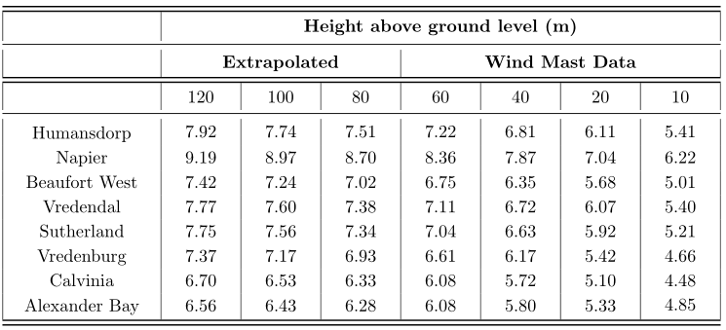
Table 2: Increase in mean wind speed (%) for 2011 WASA wind data (62m hub height as reference).
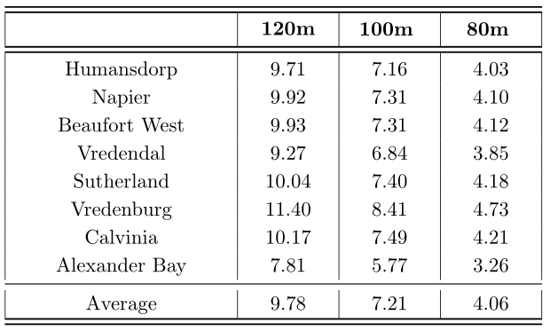

Figure 1: Graph of 2011 average wind speed vs. height data from Table 1.
Potential of wind energy
Up to 20% of the energy generation capacity of a country can be supplied by wind energy. Thereafter grid balancing becomes costly. Wind energy facilities are often stereotyped as being unpredictable and highly variable. This is not true, however, due to the following factors:
- Wind energy facilities are geographically diverse; “The wind is always blowing somewhere”;
- Wind can be forecast, just like temperature and rainfall;
- Wind patterns often repeat themselves.
Wind energy does not need to be “backed-up” by conventional forms of energy generation on a 1 MW conventional power for 1 MW wind power basis; it is often closer to 0MW to 1MW. As found by the American Utility Wind Interest Group:
“The results to date also lay to rest one of the major concerns often expressed about wind power: that a wind plant would need to be backed up with an equal amount of dispatchable generation. It is now clear that, even at moderate wind penetrations, the need for additional generation to compensate for wind variation is substantially less than one-for-one and is often closer to zero.”*
*American Utility Wind Interest Group (Nov. 2003). Wind Power Impacts on Electric-Power-System Operating Costs Summary and Perspective on Work Done to Date November 2003. Tech. rep. 2004 Lakebreeze Way, Reston, VA.

- STRUCTURAL DESIGN AND FEM

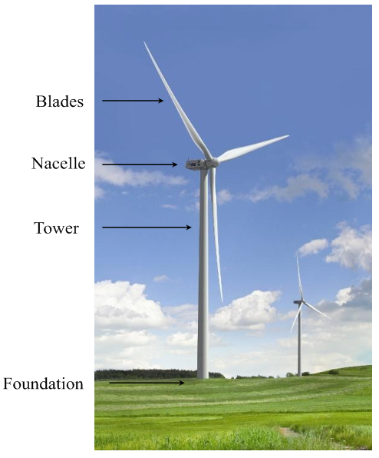
Figure 2: Wind turbine components.

Structural Design
Standards/design codes used in the design of the towers and foundations:
- SANS 10160-1:2010.Basis of structural design and actions for buildings and industrial structures Part 1: Basis of structural design;
- SANS 10160-3:2011. Basis of structural design and actions for buildings and industrial structures Part 3: Wind actions;
- IEC 6400-1:2005. Wind turbines: Design requirements;
- ASCE/AWEA RP:2011. Recommended practice for compliance of large land-based wind turbine support structures;
- FIB Model Code 2010. International Federation for Structural Concrete (fib) 2010: Model Code 2010;
- EN 1992-1-1:2004 (Eurocode 2): Design of concrete structures - Part 1-1: General rules and rules for buildings;
- DNV/RisØ, 2002: Guidelines for design of wind turbines;
- DS412:1998. The Danish code of practice for loads for the structural use of steel;
- DS449:1983. The Danish code of practice for the design and construction of pile supported offshore steel structures;

Steel towers designed for buckling capacity, material strength and tower stiffness for natural frequency requirements.
Concrete towers designed for material strength, tensile stresses are kept below the tensile limit of the 50 MPa concrete by post-tensioning.
Hybrid towers designed as a concrete and steel section separately.

FEM
Designs verified through the use of the Abaqus Finite Element Method (FEM) software.
Each of the 9 models subjected to:
- Modal Eigen-frequency (natural frequency) analysis;
- Buckling analysis;
- Static load analysis to check deflections, compare tower stresses and to include the P – Δ effect for the tower-top weight;
- Ground taken into account through the use of spring-supports.
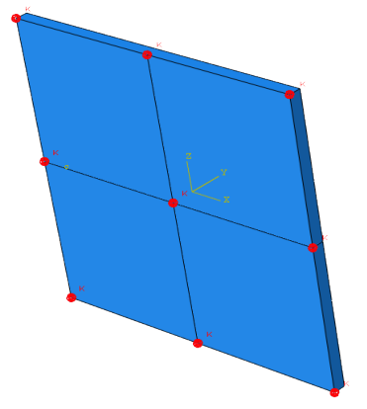
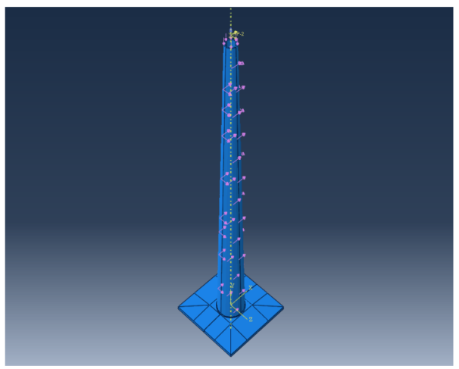

Figure 3: Ultimate loads applied to the tower and foundation structure and illustration of spring support positions on the bottom of the foundation.

- RESULTS

Tower and foundation

Tables 3, 4 and 5 show the final dimensions of the designed wind turbine towers.

Table 3: Steel tower dimensions.
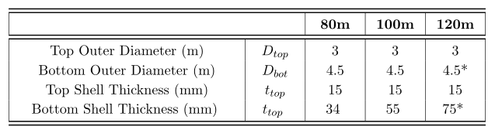

Table 4: Concrete tower dimensions.
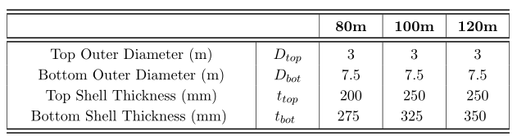
Table 5: Hybrid tower dimensions.
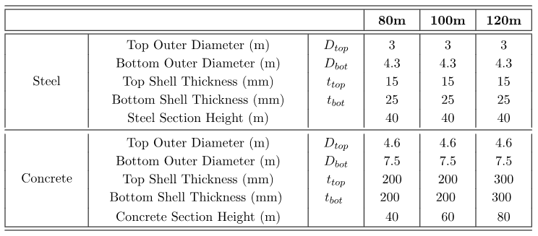

The concrete sections are substantially thicker than their steel counterparts, due to the limited capacity for tension and compression strength as well as material stiffness.

Table 6 shows the concrete material and flexural reinforcing requirements of the foundations. An increase in tower height requires an increase in foundation concrete volume for one of the following reasons:
• To provide extra weight to counter the tower overturning moment;
• To provide extra foundation height to increase the shear resistance of the concrete;
• To increase the spread area of the foundation to prevent bearing capacity failure;
• To provide more weight at the base in order to raise the natural frequency of the system.

Table 6: Foundation concrete and steel reinforcing requirements.
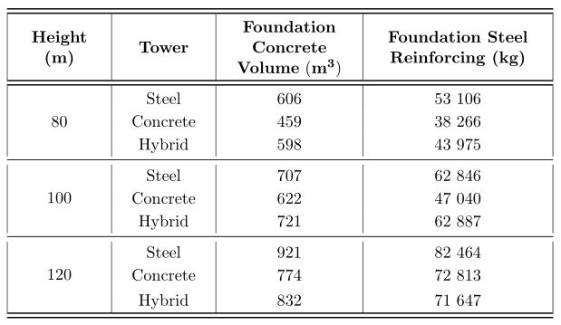

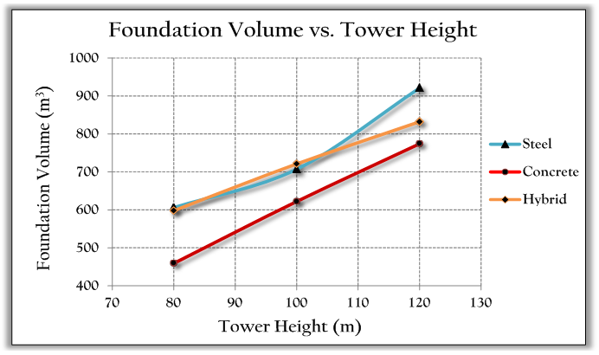
Figure 4: Foundation concrete volume requirement vs. tower height.

FEM Results

Natural frequency

The first natural frequency of each tower is of interest, to compare to the allowable frequency bands. All the towers were within the allowable range with little or no change to design, with the exception of the 120m steel tower. This tower could not be made acceptably stiff; the towers natural frequency fell just below the required limit. An illustration of the various tower natural frequencies is shown in Figure 5. The results from the Abaqus analyses are shown in Table 7.
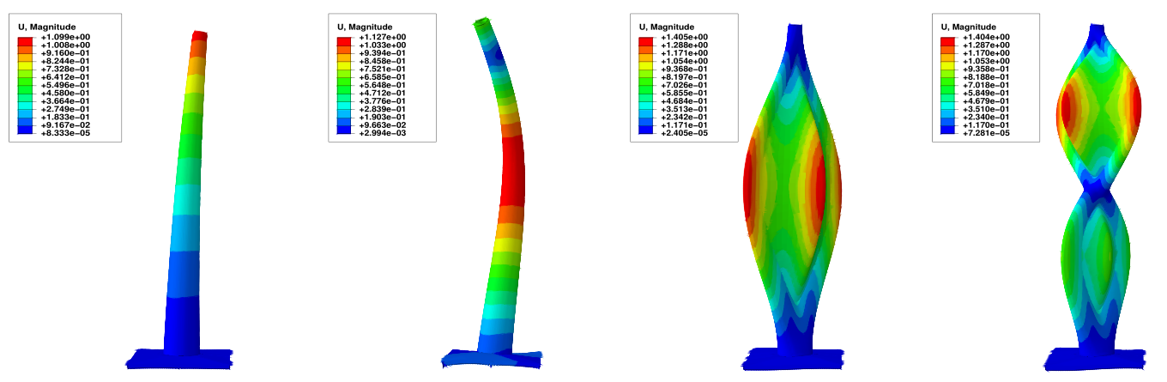
Figure 5: Natural frequency illustration of the 80m concrete tower.

Table 7: First tower natural frequency results obtained from the Abaqus modal analyses.
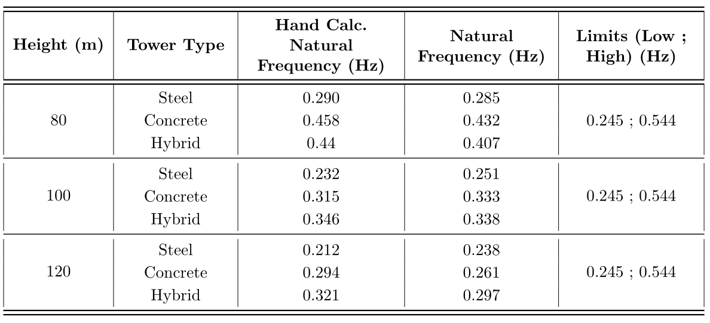

Buckling Analysis

The buckling analyses carried out on the concrete towers showed that the buckling resistance decreases considerably with increasing hub height. The trend shows that buckling may be a governing design factor to consider in the design of concrete towers taller than 120m. The buckling resistance of the hybrid towers is governed by the steel portion on top. The buckling strength of the steel towers can be seen to, counter-intuitively, increase with increasing tower height. This is due to the need for the increased shell thickness to comply with the natural frequency-stiffness requirements. Table 8 shows the results of the Abaqus buckling analyses.

Table 8: Abaqus tower buckling analysis results.
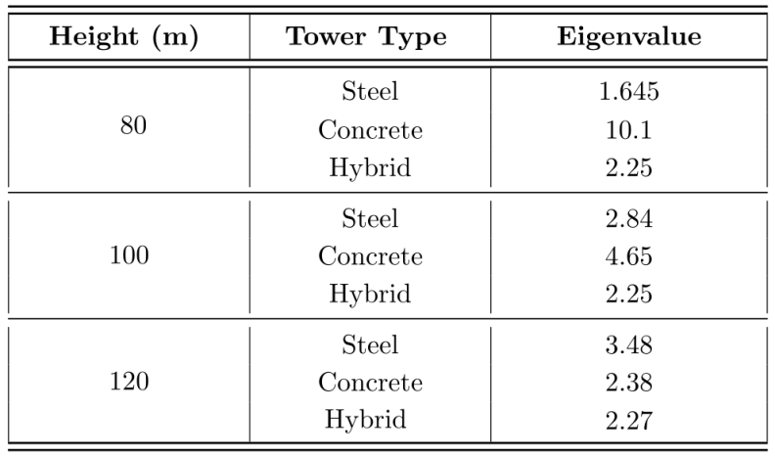
Static load analyses

The tower stresses calculated by hand are shown to be conservative, as expected, in comparison to the results obtained from the Abaqus static load analyses. The chosen sign convention indicates tension stresses as negative and compression stresses, positive.

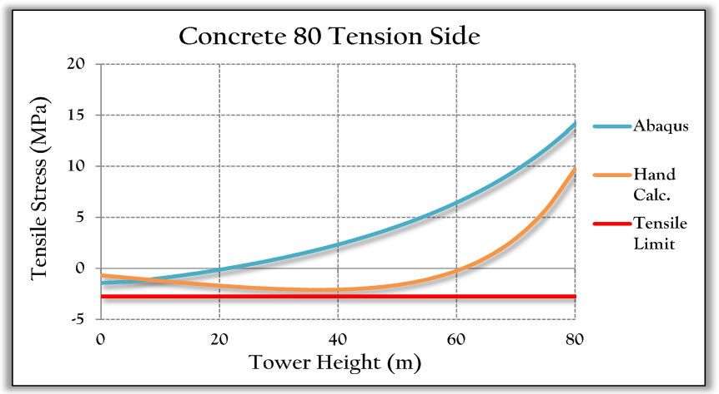
Figure 6: Windward, tension side stress comparison between hand calculations and FEM results for the 80m tall concrete tower.

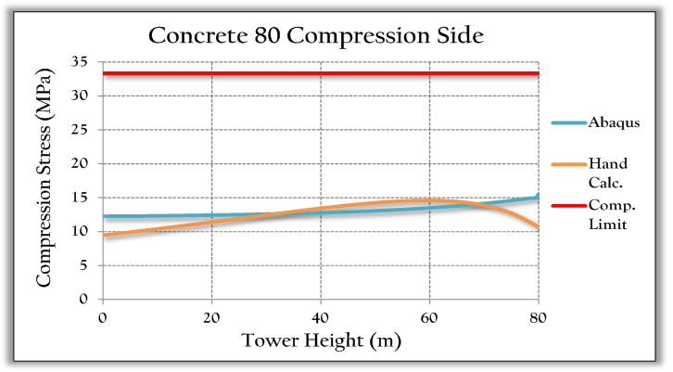
Figure 7: Leeward, compression side stress comparison between hand calculations and FEM results for the 80m concrete tower.

Post-tensioning requirements

The hybrid towers are shown to require more initial prestressing force than the concrete towers, despite the concrete sections being longer for the concrete towers. The concrete towers have thicker sections than the concrete portion of the hybrid towers and hence require less post tensioning. The losses in prestressing force in the concrete towers are thus considerably higher than in the hybrid towers. A designer may optimize the section thickness in order to use less post-tensioning if desired.

Table 9: Tower post-tensioning requirements. (PS – Pre-stressing, MBL – Minimum Breaking Load)
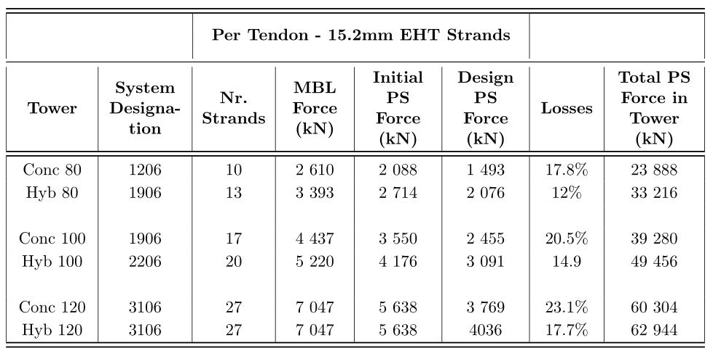

Cost comparison

The costs used in the comparison were obtained from South African manufacturers and suppliers and are exclusive of labour, professional design and construction fees, due to the material cost comparison nature of this project. Table 10 and Figure 8 show that the concrete and hybrid towers are less material cost-intensive than the steel towers, particularly for the 100 and 120m towers. The trend shows that the hybrid towers will become more cost effective than the concrete towers at hub heights greater than 110-115m. The steel towers are shown to be disproportionately material cost intensive at hub heights greater than 100m.

Table 10: Total tower and foundation material costs.
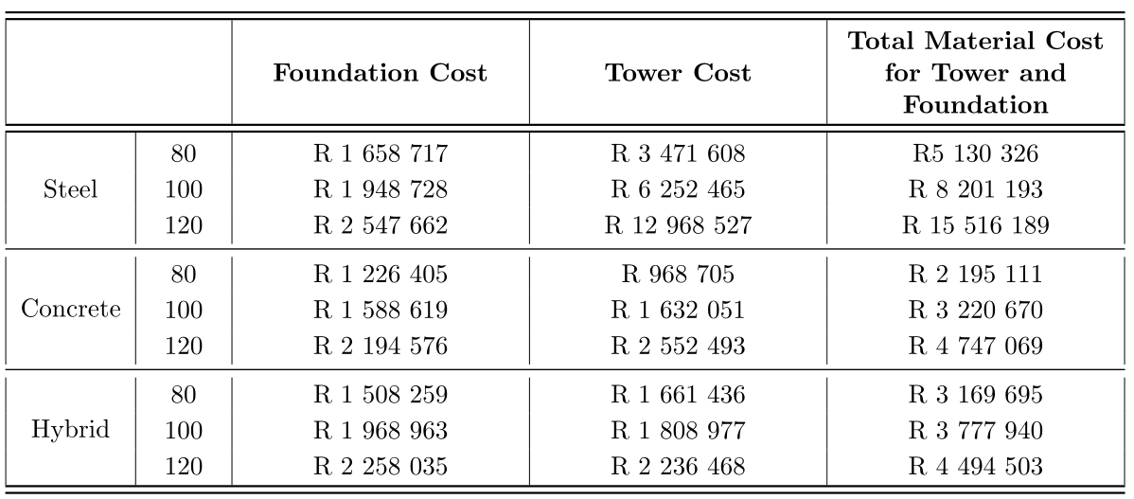
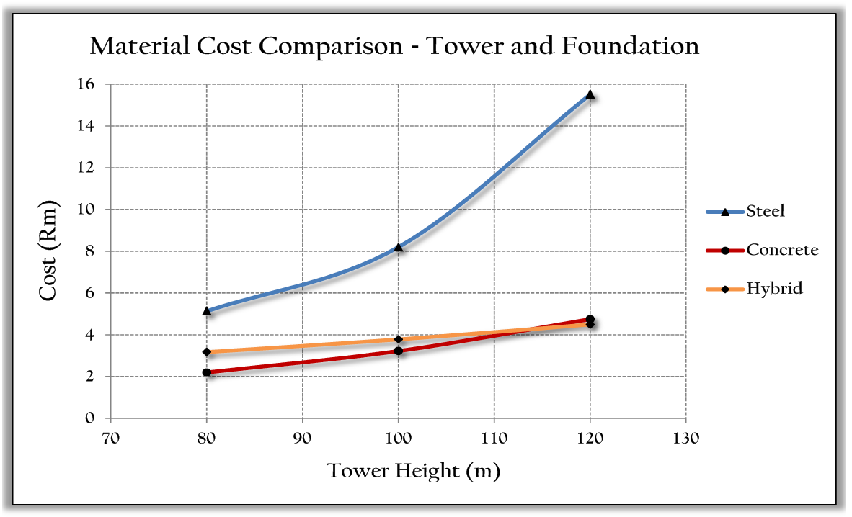
Figure 8: Tower material cost comparison for the 9 wind turbine towers and foundations.

In light of the material cost comparison, a graph comparing the likely cost of the various towers and foundations was deduced. Note that this graph (Figure 9.15) is a deduction, based on the calculated material costs and serves as more of an illustration of how the costs of concrete and hybrid become more competitive for taller towers. The intersections of the various towers are therefore, not fully accurate and it may be that the steel towers are still more cost-effective for a 100m hub height.

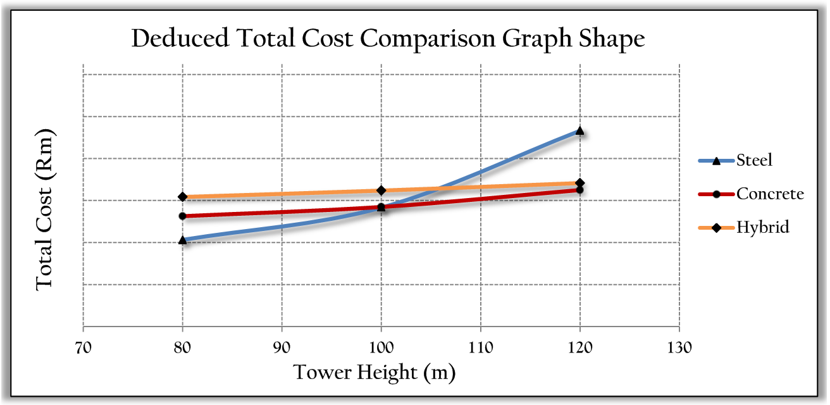
Figure 9: Total cost comparison graph shape postulation.

Revenue Generation Results

The increase in hub height from 80 to 100 and 120m will result in increased revenue generation. The following is an example of how the revenue would be increased, as a consequence of using taller towers. The data used here is from the Napier WASA mast. This specific site has a mediocre increase-in-wind-speed versus height for South Africa and serves as a good example of how an increased hub height can be beneficial to both investor and power utility. The increased revenue generation of the wind turbines for the tower heights greater than 80m are shown in Tables 11 and 12, for a Vestas V112 3MW turbine. The wind speed increase is given with reference to the 80m hub height.

Table 11: Revenue per tower height and calendar year
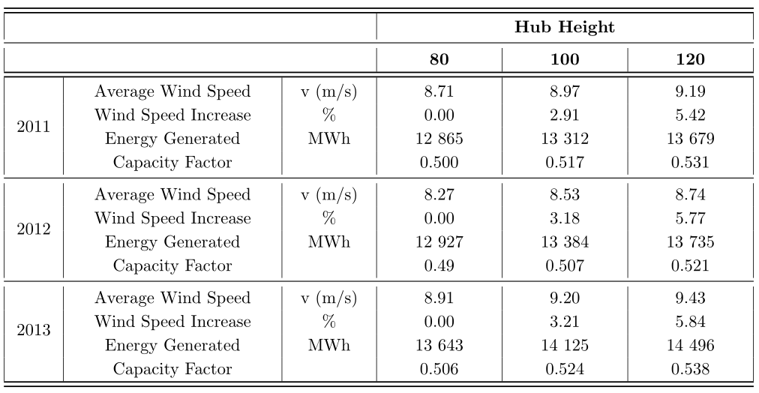

Table 12: Increase in revenue generated due to taller towers.
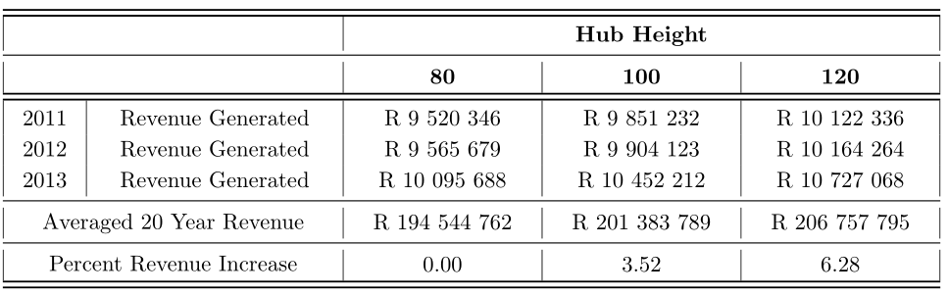

CONCLUSIONS

- The design of the foundation for the steel and hybrid towers was governed by the weight of the foundation needed to stabilize the structure against overturning for the case of water table at ground-surface level.
- The foundation designs of the concrete towers were governed by a combination of bearing capacity and foundation weight required to stabilize against overturning, also for the case of water table at ground-surface level.
- The design of the reinforcing in the foundation was always far below the minimum required amount for the section, as stipulated in Eurocode 2. The amount of reinforcing steel in the foundation was determined by this minimum requirement, although this may not be the case when designing for IEC wind class II or I.
- None of the foundations are subject to punching shear failure, even without punching shear reinforcement, although the concrete towers were just under the limit of requiring punching shear reinforcement.
- Considering the tower designs, the steel tower design was governed by the natural-frequency stiffness requirements of the tower, primarily, to ensure that the natural frequency lies within the acceptable limits as determined by the choice of turbine, but also to limit deflections.
- The design of both the concrete and hybrid towers was governed by the tensile resistance of the concrete and post-tensioning combination.
- The material cost of the studied steel towers and foundations in a South African context, are higher than their concrete and hybrid counterparts, particularly for hub heights in excess of 100m.
- The increased revenue, due to increases in hub height from 80 to 100 and 120m for a Vestas V112-3MW turbine, was shown to be in the vicinity of 3.52 and 6.28 percent respectively, with an average capacity factor increase of the same magnitudes.
- There is potential financial and power-generation reward in using taller towers in South Africa.

