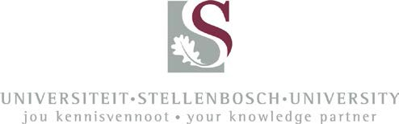

POSTGRADUATE BURSARY

awarded by

The Department of Civil Engineering Stellenbosch University

from the

AURECON BURSARY FUND FOR POSTGRADUATE STUDIES IN CIVIL ENGINEERING

2018

A number of bursaries are available for full-time postgraduate studies towards the degrees MEng (Research) or MEng (Structured) or PhD in Civil Engineering at Stellenbosch University.

Bursary value: MEng R115,000; PhD R150,000, all inclusive

Conditions: The bursaries are available for historically disadvantaged South African students. Please see the attached contractual agreement with the Department of Civil Engineering for further details.

Application process:
- Please complete the application form and submit it by email or deliver it to the contact person. The deadline for submitting an application is 30th October 2017.
- All applications are evaluated by a committee consisting of the Head of Department and Coordinator of Postgraduate Studies of the Civil Engineering Department, Stellenbosch University, and delegates of Aurecon South Africa (Pty) Ltd, sponsors of the bursary.
- Candidates will be informed of the outcome by 30 November 2017.

Contact Person:
Mrs Alet de Waal-Louw, room S404, Civil Engineering building, Stellenbosch University. Email: adwl@sun.ac.za

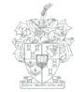
F a ku l t ei t I ng e ni e ur s w e s e
  - F a c ul t y o f E ng i ne e r i ng
D ep a r t em e n t S i v i e l e I n ge n i e u r s w es e • D e pa r t m e n t of C i v i l E ng i ne e ri ng

Privaatsak/Private Bag X1 • Matieland, 7602 • Suid-Afrika/South Africa Tel: +27 21 808 4369 • Faks/Fax: +27 21 808 4351
E-pos/E-mail: adwl@sun.ac.za • Web: http://www.civeng.sun.ac.za

